**Restaurant Management System: Streamlining Operations and Enhancing Dining**

A MINI PROJECT REPORT

Submitted By

RAHGUL S - (220701212)

In partial fulfillment for the award of the degree of

BACHELOR OF ENGINEERING

IN

COMPUTER SCIENCE AND ENGINEERING

RAJALAKSHMI ENGINEERING COLLEGE (AUTONOMOUS) THANDALAM

CHENNAI-602105 2024-2025

**Table of Contents**

1. Introduction
2. Abstract
3. Problem Statement
4. Objectives
5. System Requirements and Scope
6. Software Description and Key Features
7. Programming Languages and Technologies Used
8. Code Implementation
9. Output(UI)

10.Results and Analysis

11.Conclusion

**1. Introduction**

The restaurant industry is increasingly adopting digital solutions to improve customer experiences and streamline operations. Many traditional restaurants rely on manual processes for table reservations, customer feedback collection, and menu updates, which can lead to inefficiencies and errors. As a result, customers often face delays and a suboptimal dining experience, while managers struggle with limited insight into restaurant performance. This report discusses a **Restaurant Management System (RMS)** that integrates online reservations, digital menus, real-time analytics, and feedback mechanisms to address these challenges. By automating key tasks, the RMS aims to enhance customer satisfaction and operational efficiency.

**2. Abstract**

This Restaurant Management System (RMS) is designed to modernize and optimize restaurant operations. The system focuses on improving three main areas: customer experience, operational efficiency, and data-driven decision-making. Key features include online reservations to simplify the booking process, a digital menu with gallery options to showcase dishes and ambiance, a feedback collection system for real-time customer insights, and an analytics dashboard that empowers managers to make informed decisions. By reducing manual errors, optimizing workflows, and collecting actionable feedback, the RMS aims to elevate the restaurant experience for both customers and management.

**3. Problem Statement**

The traditional approach to restaurant management presents numerous challenges, primarily due to outdated manual processes. The main issues identified include:

1. **Manual Processes:** Inefficient table reservation systems and outdated menus create confusion and reduce customer satisfaction. Reservations are prone to errors, leading to overbooking, long wait times, and customer dissatisfaction.
2. **Limited Feedback Mechanisms:** Many restaurants lack effective methods for gathering and analyzing customer feedback. Without this information, managers miss opportunities to understand customer preferences and address service quality issues proactively.
3. **Operational Inefficiencies:** Manual workflows increase the risk of errors in order processing, inventory management, and staff scheduling, which can lead to poor service and management challenges. These inefficiencies hinder the restaurant's ability to provide a seamless dining experience and reduce overall productivity.

**4. Objectives**

The RMS aims to meet the following objectives:

* **Streamline Booking Processes:** Implement an online reservation system to reduce the manual workload, minimize errors, and enhance convenience for customers.
* **Showcase Menu and Ambiance:** Provide a digital menu with high-quality images of dishes and a gallery feature to showcase the restaurant's ambiance, allowing customers to make informed choices.
* **Gather Customer Feedback:** Introduce a structured feedback mechanism to collect real-time insights from customers, enabling managers to identify and address areas for improvement.
* **Enable Data-Driven Decisions:** Offer real-time analytics on reservations, customer preferences, and popular dishes to support informed decision-making by management.

**5. System Requirements and Scope**

**Functional Requirements**

1. **Online Reservation System:** Allow customers to book tables online, view available slots, and receive instant booking confirmations.
2. **Digital Menu and Gallery:** Enable customers to browse dishes with photos and descriptions, showcasing the restaurant’s offerings in an attractive format.
3. **Real-Time Analytics Dashboard:** Provide management with insights into reservations, customer feedback trends, and other key performance indicators.
4. **Feedback Collection System:** Collect customer feedback and allow management to analyze trends to improve service quality.

**Non-Functional Requirements**

1. **Performance:** The system should handle high volumes of users, particularly during peak dining hours.
2. **Security:** Protect customer data and ensure compliance with data protection regulations.
3. **Usability:** Ensure user-friendly interfaces for customers, staff, and managers.

**Scope**

The RMS covers core restaurant management functionalities such as reservations, menu presentation, analytics, and feedback. It does not include back-end functions such as supplier management or accounting.

**6. Software Description and Key Features**

The RMS includes various features to address both customer needs and operational efficiency:

* **Online Reservations:** This feature allows customers to make reservations from a web interface or mobile app. It provides real-time availability, enables selection of party size and time, and generates instant confirmations.
* **Digital Menu with Gallery:** A visually appealing menu system that allows customers to view dishes with high-quality images and descriptions. This gallery feature includes sections showcasing the ambiance and decor, enticing potential customers to visit.
* **Feedback System:** Customers can submit feedback on their experience, providing management with valuable insights into service quality. This feedback can be analyzed to identify trends and areas that need improvement.
* **Real-Time Analytics:** A dashboard provides management with data on reservations, popular dishes, and peak dining times, enabling data-driven decision-making.

**7. Programming Languages and Technologies Used**

* **Frontend:** HTML, CSS, JavaScript and Boootstrap are used to build responsive and user-friendly interfaces. Libraries such as React or Angular may be used for dynamic content rendering.
* **Backend:** Python, PHP as the backend framework to manage server-side operations, data processing, and logic.
* **Database:** MySQL is used for efficient data storage, supporting information such as customer records, reservations, orders, and feedback.
* **APIs and Libraries:** Integration of third-party libraries for data visualization, authentication, and analytics enhances the system's functionality.

**8. Output (UI)**

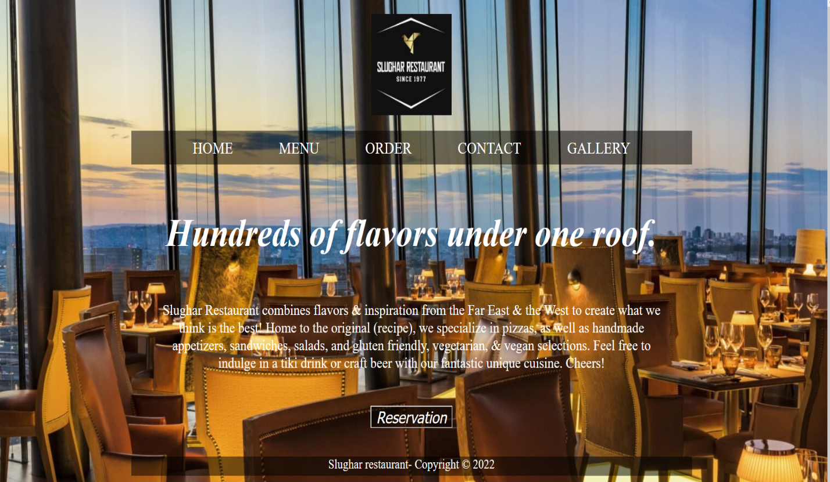

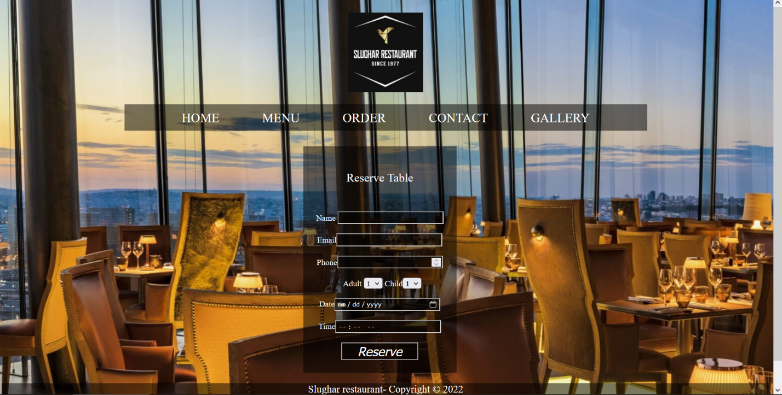

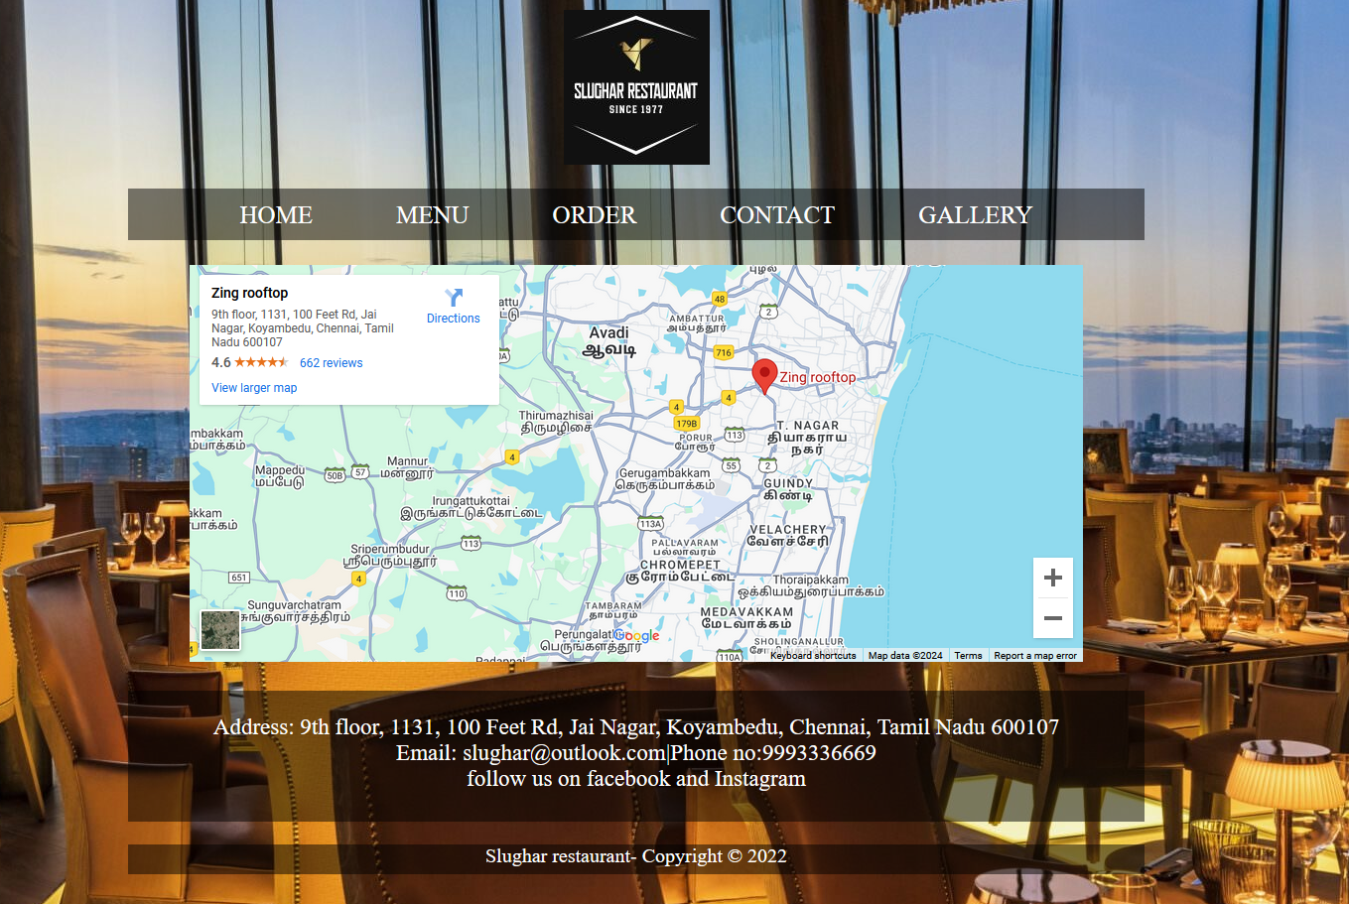

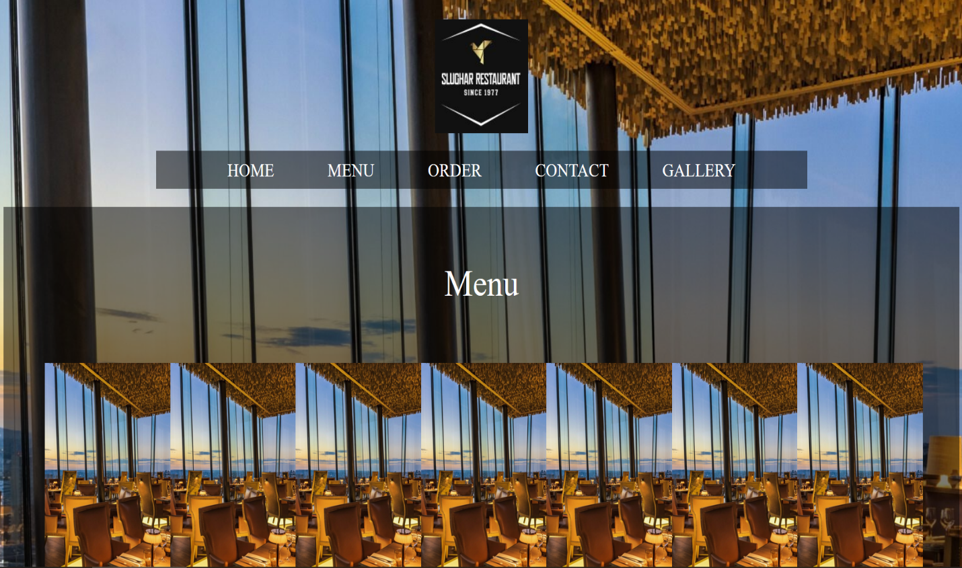

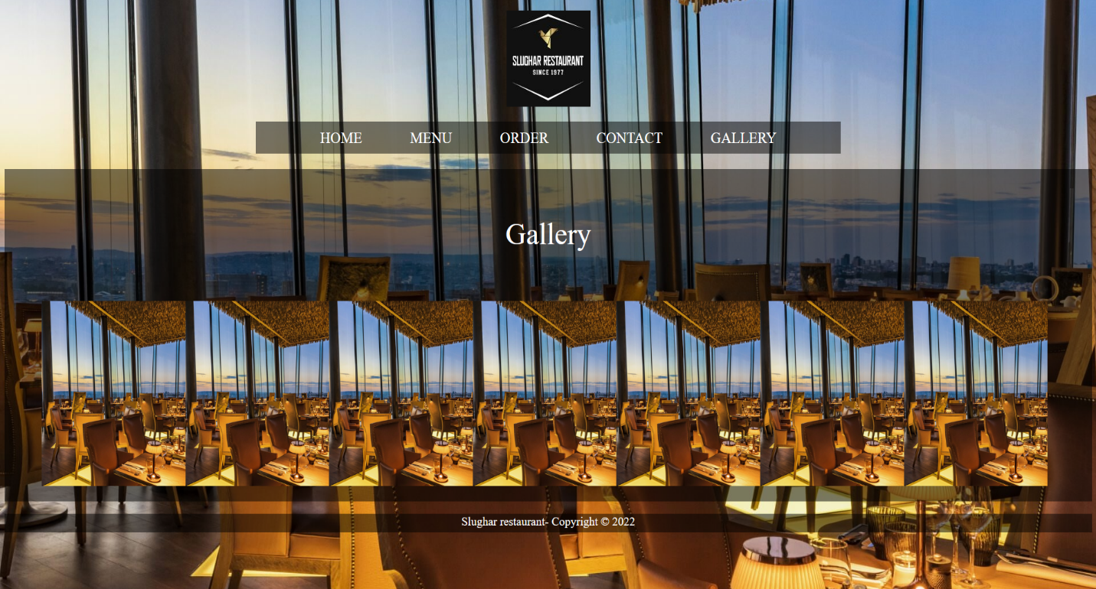

**9. Results and Analysis**

The implementation of the RMS has shown promising results in improving restaurant operations and customer experience. Key outcomes include:

* **Enhanced Efficiency:** The online reservation system minimizes manual errors and streamlines the booking process, leading to shorter wait times and a better customer experience.
* **Improved Customer Satisfaction:** Feedback indicates that customers appreciate the digital menu and streamlined reservation process.
* **Data Insights:** The analytics dashboard enables managers to track customer preferences, high-demand dishes, and peak times, allowing them to make informed decisions.

**10. Conclusion**

The Restaurant Management System (RMS) successfully addresses common challenges in restaurant management by automating reservations, showcasing a digital menu, and collecting customer feedback. By providing real-time analytics and optimizing workflows, the RMS enhances operational efficiency and customer satisfaction. Future improvements could include integration with loyalty programs, AI-driven customer recommendations, and mobile app support. This project demonstrates the potential of technology to transform traditional restaurant operations, making them more efficient, insightful, and customer-friendly.